**CSCI.258: Introduction to Operating Systems using UNIX**

**UNIX Login Procedure**

**Your Username**: First letter of first name and first seven characters of last name together make you username. For example, my name is Suban Krishnamoorthy. According to the given convention, my username is skrishna. Notice that the username is all lowercase. Remember, UNIX is case sensitive, that is, A is not same as a.

**Your Starting Password**: Username followed by the last 2 digits of your student ID. For example, assume my ID is 123456789, the default starting password is skrishna89 for my username skrishna.

**Changing Your Password**: Immediately after login, you must change your password for the security of the system and your account. Changing your password will prevent others from accessing, deleting, and modifying your files.

You can change your password using the ***passwd*** command. Immediately after login, you will see $ at the last line on the screen. This $ is called the shell prompt. On that line type ***passwd*** and press ***Enter*** key. First, the system will prompt (ask) you for **Old Password**; for this type your current password and press **Enter** key. Second, it will ask for **New Password**. Type new password and press Enter key. Third, the system will ask you to retype the new password. **Retype the password** and press **Enter** key. On successful completion, you will see the shell prompt $. The following lines show what has been described so far:

$ passwd

Old Password:

New password:

Retype password:

$

**Selecting Secure Password**: In order for the password to be secure, it should be 10 characters or more long. Use a combination of uppercase letters, lowercase letters, digits, and special character. Short passwords, words in the dictionary, popular words, and names are easy to crack. Do not use your login name as username.

**UNIX Login Procedure**: The UNIX server we have is HP-UX from HP. With your username and password, you can login to HP-UX UNIX server by running the PuTTY program and following the steps given below. The link to download PuTTY, a free software, is given in the syllabus.

1. After double clicking the PuTTY icon, you should see a screen like the one below

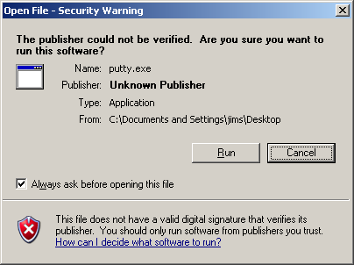

2. Enter **192.168.200.230 (on-campus)** or **134.241.37.230 (off-campus)** in the Host Name (or IP address) field. Leave the port set to 22.

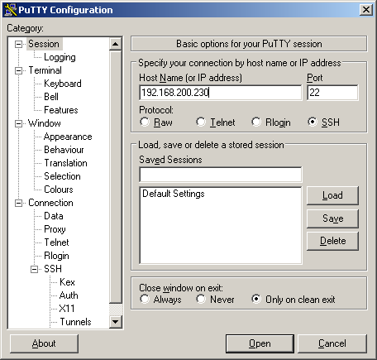

3. Enter your user name and password

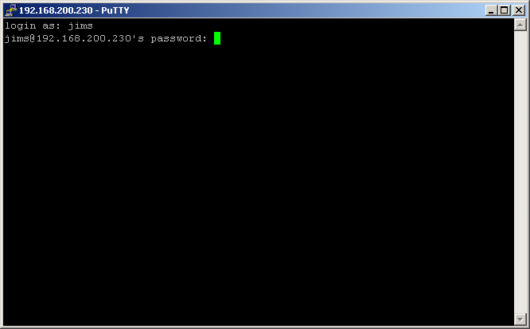

4. After logging on, you should receive a screen similar to the on below

